Bad time to fall Sick? Assessment of Petrol Subsidy Removal and Deregulation of Foreign Exchange (FOREX) on Nigeria’s Healthcare System
Olasupo Thompson, Ridwan Idris, Surajudeen O. Oladotun and Bamidele Jinadu

Corresponding author: thompsonoo@funaab.edu.ng

Abstract
Leaders around the world make decisions and set policies based on specific principles and environmental factors. The monetary policies introduced by President Bola Ahmed Tinubu, including the removal of subsidies and the deregulation of foreign exchange, have had profound effects on various sectors and individuals, yet their impact on healthcare has not been thoroughly examined. This paper investigates how these policies have influenced Nigeria’s health sector. Through a qualitative analysis using primary and secondary sources such as books, media reports, and interviews, the study finds that these policies have raised the costs of essential drugs and healthcare services. While they have broadened access to health, they have also led to the exit of major pharmaceutical companies that Nigeria has relied on for years. Government initiatives, including palliatives and support for local production, have had limited success due to problems like corruption, inconsistent policies, lack of political will, and insufficient healthcare funding. The paper emphasizes the need for enhanced healthcare funding, greater support for domestic drug production, and stronger political commitment.
Key words: healthcare, subsidy, policies, foreign exchange, migration, doctors

Introduction
Health is fundamental to a nation’s survival and serves as a key indicator of national progress. A healthy society or nation is more likely to experience growth and maintain a thriving population. The gap between healthcare systems in developed and developing countries is vast, reflecting significant differences in life expectancy. In developed countries, average life expectancy ranges from 70 to 80 years, while in third-world or developing nations, it hovers between 40 and 55 years. This disparity is evident in countries like Nigeria.
Nigeria, the most populous country in Africa with approximately 215 million people, also holds the title of the largest Black population globally. Despite its wealth in human and natural resources, Nigeria remains one of the poorest nations. Around 133 million Nigerians live in poverty, and this number is expected to increase, with most of the population surviving on less than $2.15 per day (World Bank, 2022). In 2023, Nigeria's Human Development Index (HDI) was 0.548, placing it 161st out of 193 countries (UNDP, 2024). The unemployment rate, previously estimated at 33.3 percent and expected to reach 40 percent by 2023, was controversially revised to around 4 percent in June 2023. The national average cost of a healthy diet rose to N982 in March 2024, a 4.7 percent increase from February 2024. The country’s healthcare system heavily relies on imports, with drug imports totaling $2.4 billion in 2020 but declining to $1.37 billion in 2021 and $1.05 billion in 2022 due to foreign exchange pressures. Additionally, Nigeria's annual food inflation rate soared to 40.01 percent in March 2024, up from 24.45 percent in March 2023. To address these challenges, the government has implemented various subsidies as a form of intervention.
President Bola Ahmed Tinubu after his election and inauguration introduced some significant monetary policies. The first major step was the elimination of the fuel subsidy, followed by the devaluation of the foreign exchange through the floating of the naira. Devaluation serves two primary purposes: it makes a country's exports cheaper for international buyers and increases the cost of imports, thereby discouraging them with the ultimate goal of addressing trade deficits. These actions have had substantial impacts across various sectors, including healthcare. While there is a growing body of literature on healthcare in Africa (Balogun, 2021; Doyle, 2022; Thompson, 2024) and the effects of policies on healthcare (Thompson, Kanumuangi, Aduradola, and Raheem, 2023), there has been insufficient focus on how decisions like subsidy removal and currency devaluation specifically impact the healthcare industry.
This paper aims to explore the effects of the government's monetary policies on the removal of the petrol subsidy and the floating of the foreign exchange on Nigeria's healthcare sector. It seeks to answer key questions: What is the impact of these decisions on the healthcare sector? How has the government responded to the challenges arising from these policies? How effective have these responses been? The insights gained from these questions will help policymakers craft more effective legislation and will also benefit development partners, stakeholders, researchers, and development experts. The paper utilizes both primary and secondary sources with interviews and observations forming the primary data, while existing literature, newspapers, and journals constituted the secondary sources.
Understanding Nigeria’s Subsidy Regime and Floating of the Naira
For several decades, the Nigerian economy has relied on government interventions in the form of subsidies on fuel, foreign exchange, education, electricity, and more. Among these, fuel subsidies have been particularly contentious, despite their long history. Introduced in the 1970s and formalized in 1977 with the passage of the Price Control Act, the aim of fuel subsidies was to regulate the price of goods, including petrol. Although subsidies were implemented with good intentions, they have been plagued by significant corruption and mismanagement in Nigeria. The history of fuel subsidy adjustments began during the regime of Ibrahim Babangida, who raised fuel prices multiple times in the late 1980s and early 1990s. Subsequent administrations, including those of Ernest Shonekan and Muhammadu Buhari, also attempted to remove fuel subsidies but faced strong public resistance, leading to the reversal of these decisions (Yunusa et al., 2023).
From 1999 to 2016, the Nigerian government made several attempts to modify petrol subsidies. For example, subsidies were central to the economic policies of Olusegun Obasanjo, Umaru Yar’Adua, and even Goodluck Jonathan. However, efforts to remove these subsidies often met significant opposition. A notable instance was in 2012, when Goodluck Jonathan’s attempt to remove the subsidy sparked the "Occupy Nigeria" protests (Yunusa et al., 2023). Similarly, the Muhammadu Buhari administration faced public rejection when it tried to either partially or fully remove subsidies through his tenure. The resistance appears to stem not from the removal of subsidies itself, but from concerns over how the government and its agencies would utilize the savings. Garba (2023) suggests that political, social, and economic factors all play a role in the ongoing debate about subsidy removal in Nigeria. This test of strenght will later be tested immediately after the election victory of President Bola Tinubu.
During his inaugural speech at Eagle Square, Abuja, on May 29, 2023, President Tinubu declared the end of fuel subsidies with the statement, “Subsidy is gone.” This announcement led to an immediate spike in fuel prices to N 540 (US$1.5) per litre. The Nigeria Labour Congress initially threatened industrial action in response but later withdrew after negotiations. The debate over subsidy removal continues, influenced by various factors, including public sentiment, international oil prices and politics especially of the neoliberal sharks (Chang, 2007), government finances, and national stability. President Tinubu’s decision to eliminate the petrol subsidy and float the Naira aimed to maintain Nigeria's financial stability and reignite economic growth. However, the announcement, made on his inauguration day, triggered a sharp increase in commodity prices (Anichukwueze, 2024).
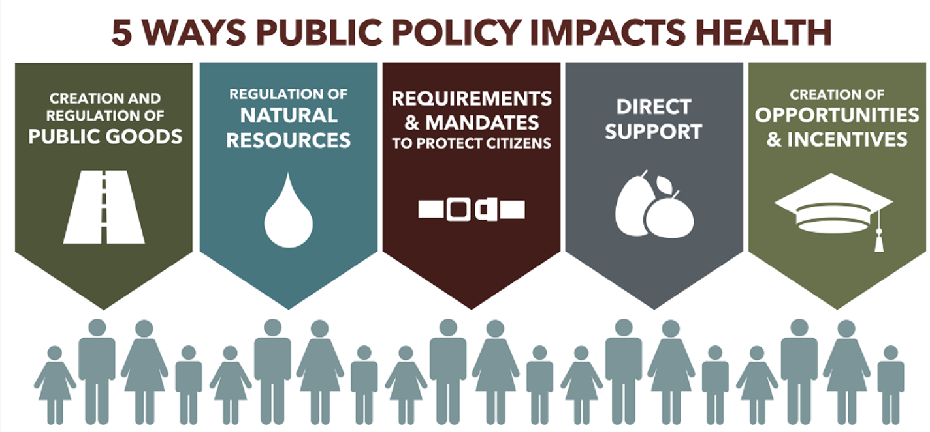Source: Spears (2017)

President Tinubu justified his tough economic decisions by arguing that such measures are essential for long-term stability and sustainable economic growth. He emphasized the importance of budgetary restraint, accountability, and transparency, stating that these policies would help build a more resilient and competitive economy. Tinubu also advocated for the unification of the Naira to eliminate artificial values, reduce corruption, and enhance Nigeria's ability to compete on the global stage. Despite the anticipated challenges, he underscored the importance of inclusive governance and effective communication to manage the transition, along with implementing complementary measures to mitigate the impact on vulnerable populations (Anichukwueze, 2024). However, since President Tinubu took office, the steady depreciation of the Naira against the US dollar and other major global currencies, coupled with the deregulation of the foreign exchange market, has triggered a series of economic crises, with healthcare delivery emerging as one of the most affected sectors. By February 2024, the official exchange rate had plummeted from N463.38/$ to N1,665.5/$. Meanwhile, the Naira's value in the parallel market soared to N 1,800/$, up from N762/$. Although much scholarly work has been done on the impact of the economy on healthcare, there has been insufficient focus on this two monetary policies in recent times.
Nigeria’s Health system
Nigeria's health system is shaped by three distinct phases: pre-colonial, colonial, and post-colonial. Before colonization, traditional medicine relied heavily on indigenous herbal treatments and spiritual practices (Oluwabamide, 2013). Various ethnic groups, including the Yoruba, Igbo, and Hausa-Fulani, each with rich medical traditions, relied on healers and herbalists for diagnosing and treating illnesses. For example, Yoruba healers, known as “Babalawos,” combined herbal remedies with rituals to promote overall well-being (Thompson, 2021). Similarly, Hausa-Fulani healers, called “Mallams,” integrated Islamic teachings with traditional methods to maintain health and prevent disease, while the Igbo relied on “Dibias,” who were skilled in herbal medicine and divination (Idris & Olawale, 2022).
The arrival of British colonialists in the late nineteenth century brought major transformations to Nigeria’s healthcare system. Missionaries who had introduced Western medicine were supported by the British colonial government, which established Western medical practices and built urban healthcare infrastructure. Missionary hospitals were primarily intended for colonial officials and European expatriates. During this time, medical training institutions were established and the foundations of modern healthcare began to take shape, though access remained limited for those in rural areas (Paul, 2020; Nkwam, 1988).
After gaining independence, Nigeria inherited a healthcare system marked by significant inequities. Efforts to improve healthcare infrastructure, including the creation of teaching hospitals and primary health clinics in the 1970s and 1980s, aimed to enhance accessibility and quality (Abah, 2022). However, these advancements were overshadowed by persistent challenges, worsened by economic instability and political turbulence, especially during the 1980s and 1990s Structural Adjustment Programme (SAP). During this period, public healthcare funding and services diminished, leading to a rise in private healthcare options to meet growing demands (Balogun, 2021). These issues remained unresolved.
In the early 2000s, Nigeria faced severe healthcare challenges, including high rates of infant and maternal mortality and prevalent infectious diseases such as malaria and HIV/AIDS. To improve healthcare access, initiatives like the National Health Insurance Scheme (NHIS), launched in 2005, aimed to broaden coverage through insurance. Despite these efforts, issues such as inadequate funding, workforce shortages, and geographic disparities continued to affect healthcare access and quality (Agba et al., 2010). Recently, there has been a renewed focus on enhancing primary healthcare and preparing for health crises, particularly in response to global challenges like the COVID-19 pandemic. Partnerships with international organizations and the private sector have been vital in addressing healthcare issues, but lasting improvements require significant policy reforms and increased investment in healthcare infrastructure (Balogun, 2021).
METHODOLOGY
The paper adopts the qualitative research design. This methodology has been established to provide a thorough understanding of the nature of a phenomena. Data for the study was elicited from both primary and secondary sources.
The main methods for data collection included In-depth Interviews (IDI), Key Informant Interviews (KII), and observations. Interviews were conducted both over the phone and in person. Four participants for the IDI were purposively chosen from the six geopolitical zones of the country as well as based on their interest and willingness to participate in the study as shown in Table 1. Additionally, four participants were purposively selected for the KII, including a medical doctor, a pharmacist, a traditional birth attendant, and a chief matron.
S/N | Primary Data Collection | Sex |  | Total
S/N | Primary Data Collection | Male | Female | Total
1 | Key Informant Interview (KII) | 2 | 2 | 4
2 | In-Depth Interview (IDI) | 10 | 14 | 24
12 |  |  | 16 | 28
Table 1: Demographics of the Participants
Phone interviews were chosen due to the preferences of the interviewees, as well as considerations of cost and convenience. The questions were sent to participants in advance via phone and email, allowing them to thoroughly understand the issues and decide if they were willing and knowledgeable enough to participate. Consent to participate was given either orally or by phone, and responses typically lasted between two and five minutes.
Secondary data for the study were obtained from documents, videos, literature reviews, and newspapers provided by non-governmental organizations. The data were analyzed thematically and interpreted through descriptive narrative analysis. The study received ethical approval from the Department of Communication and General Studies at the Federal University of Agriculture, Abeokuta, Ogun State, Nigeria (FUNAAB/CGNS/Subsidy Removal and Health/2024/Vol. II).

RESULTS/ FINDINGS
The Impact of Subsidy Removal and FOREX Devaluation on Nigeria’s Healthcare
First, there is a high cost of prescription drugs. One of the impact of the subsidy removal is the increased the cost of purchasing prescriptive drugs across the country. IDI (Gbenguse) stated that some of the drugs that he brought few months ago had risen exponentially that he had to now start seeking alternative in traditional or home-made remedies. IDI (Kemo) puts it this way:
I now do homemade remedies particularly for malaria for myself and my children. Once we get those herbs and shrubs, we are good to go. How can one struggling to drugs of N500 and N1200 for N3000and N5000? Where do we see the money? My salary is less than N60, 000. My husband who is a taxi driver only earns less than N 2000 daily because fuel has taken the larger part of the earnings. Again I now pray that my children should not fall sick. So we now pray to God because this is a very bad time to fall sick.
IDI (Olowo) also stated that it has led to the increase in the cost of drugs. The prices of antibiotics, analgesics, hypertensive and anti-diabetic drugs, among others, have soared to between 400 and 500 per cent. This cost of drugs have left so many untreated diseases in many patents. IDI (Baba) said, “I have been having a serious moving objects and since there is this drug that I use which is now expensive, I just leave it and depend on nature”
Secondly, there is high cost of healthcare services. Be it private or public health facilities; the cost of seeing a consultant let alone affording surgery has been on the high side in recent times thereby preventing many patients or citizens from affording healthcare. IDI (OG) noted that, “it has been very hard for me to afford my medications. Though I am on National Health Insurance Scheme (NHIS) (NHIA), I still find it hard to do certain tests free. This is really affecting my purse and usually stop me from visiting the clinic when I feel I need to do so. Another IDI (Tai) said that even when he enjoys NHIS, the cost of certain tests which the scheme does not offer have really affected his health” Another IDI (Iya Bol) said that she does not know about NHIS but that she relies on agbo (local infusion) and since there is no healthcare facilities in her community. IDI (LateeA) said it increased hospital bills that members of the society including herself who is a low income earner cannot afford. Even the Coordinating Minister of Health and Social Welfare, Prof Muhammad Pate has said that while there are growing health issues like maternal, newborn, and child health, and infectious diseases such as malaria, tuberculosis, and HIV persist, non-communicable diseases like hypertension, diabetes, and cancers; the facilities available can handle them but that many Nigerians who rely on these facilities do not seek care at all due to rising cost of affordability (Adejoro, 2024a).
Third, it led to a widening access to healthcare. The inflation has hampered access to health services in the country with many sick Nigerians unable to afford medication. As one KII puts it,
It is now expensive to get food than to fall sick so no money to buy drugs now ooo. I told my wife to start plucking vegetables and not to fall sick because I don’t have money to go and be buying drugs.
Another one said that he spent more than N 500, 000 to take care of the wife’s illness only to find out that it was cancer. He went on to state that it was because of the high cost of diagnosis that made him to patronise quacks thinking it will save him some monies. Apart from the cost, there is also the challenge of transportation to the facilities. IDI (Sogo) said,
Anytime I don’t have money to visit the clinic, I will just sit at home and even when I Know that I have appointment, the cost of going to the clinic from my house is almost N3000. Imagine spending this alone for transport, what will one then spend for medications or seeing the consultant?
IDI (Iya Messi) stated that “if any of my children are sick, instead of going to hospitals, I now take advise from health professionals that live around us or sometimes, I will do home remedy first.” It is intrusive that access to healthcare have been greatly hampered as a result of inflation. This become challenge for Nigerians to buy drugs and other medical needs for the health.
Fourth, there is an increase in cost of medical equipment, tools, and consumables. It is noted that the subsidy also affected the cost of not just health equipment but also reagents and materials needed in various health institutions from machines to smallest surgical gloves. As a KII (doctor) notes, “we now pay much for those surgical or medical equipment we buy less. So there is no way we can charge less when we pay higher for these equipment.” IDI (Olowo) said: “It increased the cost of every material to be used have made health care inaccessible for the citizens”
Fifth, it has affected other aspects of public health including mental, neurological, maternal and Reproductive health. IIDI Popo said the case of her daughter almost relapsed because of the cost of getting scans done and buying her medications. DI (Iya Ada) noted that since she and her husband are not government workers and not liable to collect minimum wage, her family planning almost expired before she got money to fix it. IDI (Osho) shared same about the wife and that the cost of gold circle condom and other preventive mechanism including pads for his female menstruates have also increased and that this is a serious concern for their health. He went further to state that his wife does not like condoms and he himself does not like withdrawal method which makes it hard for both couples. He added that it was when he tried to practice the withdrawal method that led to the last baby (6th).
Sixth is Brain Drain and exodus of pharmaceutical/ medical industries. The situation is more terrifying with major drug manufacturing companies folding up their operations in Nigeria as the environment for business becomes more difficult. There is also the underlying problem of the mass exodus of medical doctors, nurses and other paramedics to Europe, the United States, Canada and Saudi Arabia for better pay and working environment.
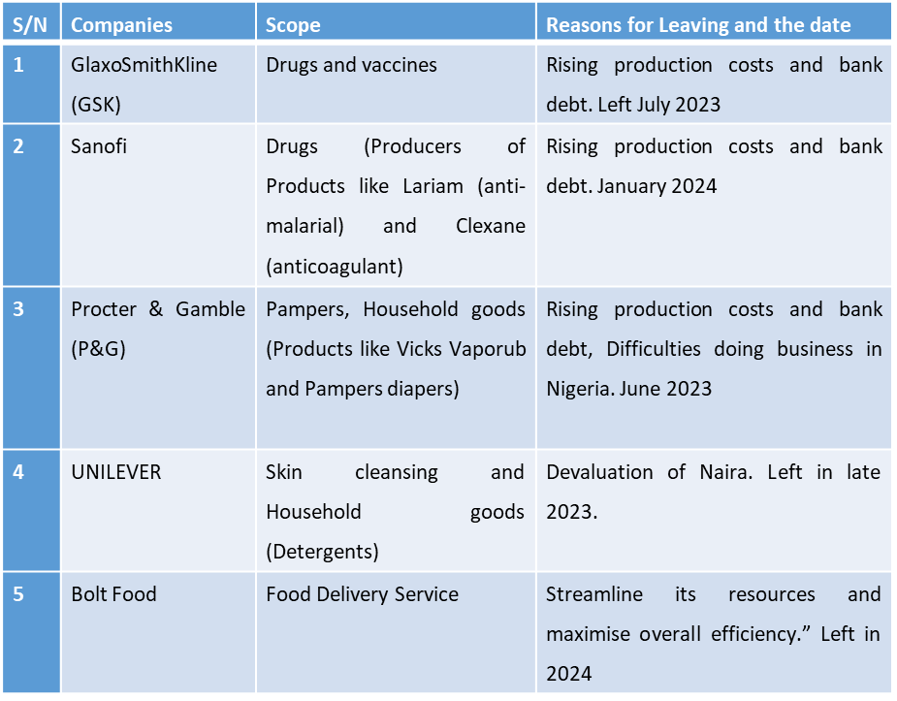Figure 1: Some Companies that Exited Nigeria and Reasons since May 2023
Source: Ikpoto (2023; Nseyen, 2024

Seventh, it has led to an over-reliance on Spiritual Intervention or Self-Help or self- medication/ unskilled health giver. When the cost of healthcare is out of the reach of the poor, they avoid going to the hospital for a doctor’s attention and resort to self-help through self-medication, patronage of quacks and indulgence in the use of herbs and other local concoctions without proven scientific bases, all of which could kill, or cause life-threatening damages to organs of the body. Others rely on prayers and spiritual interventions only. This is even of serious concern for those battling with deadly or major health complications. IDI (Afisuru) said, he now relies on his spiritual guide (Alfa) for his health. IDI (Alahja) said she now asks friends on any symptoms affecting her. IDI Popo said since the doctor once prescribed a particular drug for her knee pain, she has been buying the drug herself instead of revisiting the hospital to visit the doctor because of transportation cost and cost of scans.
Eight, drug Abuse. IDI (Iya Messi) aid, “since the subsidy and deregulation has affected cost of drugs, if I go to the hospital and they prescribe drugs for me, instead of using it three times daily, I now use it twice daily. I don’t buy up to what the doctor prescribes. I use my discretion” As a KII (Doctor A) noted that they have observed that some patients either do not use the full prescriptions or sparingly use their medications which is a symptom of under-dose in order to make it last long.
Ninth, there have been an increase in counterfeit products from food, drinks to drugs with implications on the health of consumers. As one KII (doctor) puts it,
If not because some of us are health professionals, we would have been accused of trying to kill our patients. This is because sometimes when we ask them to get certain drugs that is not available in the hospital outside; we discover a few of these drugs are either fake or adulterated. This is bad not just for the country but the health of the consumers.
Another KII (Pharmacist) noted that the exit of some of the multinational pharm companies have left a huge hole for imitation of drugs and poisons which are very important in healthcare. IDI (Apapa) said that he bought a fake Augmentin sometime on a bus when the vendor said it was N3700 when it should be sold for nothing less than N 35, 000. He furthered that it was when he showed it to his pharmacist relative that revealed that it was fake.
Finally, these have impacts on job losses. The exit of some of these pharmaceutical companies have left some or most of their workers sacked or put temporarily out of work. Indeed these workers could be the bread-winner of their families and this would have implication on their families and society. IDI (Dap) noted that after he was sacked, he has found it very difficult to get a job at his age of 56years. He furthered that most companies where he has sent his CV have been skeptical of his age and he only wished he had not told his wife to stop working.
Government Responses
The government implemented several interventions in response to the challenges faced by citizens and workers. Initially, it provided financial palliatives to ease the impact of policy changes. For six months, from September 2023 to February 2024, the government paid N 35,000 (US$23.30) monthly. While this support helped supplement the salaries of federal civil servants, it was limited to a few states. For the general public, the federal government distributed bags of rice through governors, national assembly members, and other political figures.
Additionally, there was an increase in the minimum wage. Despite the president’s campaign promise to provide a living wage, the labor union’s controversial stance on what constitutes a living wage led to a compromise at N 70,000 (US$46.66), still below the $2.15 per day World Bank threshold.
Another significant intervention involved policy changes. In January 2024, during a Federal Executive Council meeting, it was decided that the government would implement policies to boost drug manufacturing. These measures included regulating drug prices, allocating funds to the Medical and Dental Council of Nigeria (MDCN), and removing waivers for health worker recruitment, with the Ministry of Health handling these changes without bureaucratic delays (Premium Times, 2024). Following through on these commitments, in May 2024, Prof. Mojisola Adeyeye, Director General of the National Agency for Food and Drug Administration and Control (NAFDAC), introduced the “5 plus 5” regulatory scheme. This initiative grants a final five-year renewal to companies importing drugs that can be produced locally, aiming to encourage domestic pharmaceutical production and reduce reliance on imports (NAFDAC, 2024). Additionally, the Federal Government directed the creation of an executive order to address barriers to local drug manufacturing, including issues such as limited foreign exchange access, difficulties in local production, procurement challenges, policy inconsistency, and a lack of development funds for pharmaceutical manufacturing and research (Onwuzoo, 2024). Despite these efforts, there has been minimal improvement in the nation’s healthcare system or the well-being of its citizens.

Why has these Responses not been Effective?
The government’s responses have largely been ineffective due to its failure to involve stakeholders in decision-making and policy formulation. For instance, the President of the Pharmaceutical Society of Nigeria, Prof Cyril Usifoh, emphasised the necessity of consistent electricity, stable foreign exchange rates, and sound fiscal policies to tackle the situation. Usifoh said, “The government has made a policy that we should be producing more of these drugs here, but before they came up with this policy, the stakeholders were not consulted. Right now, we are dialoguing with the government. There’s a lot of discussion going on between the government and the industries.” Yet these discussions have not yielded fruits.
Another significant issue has been the departure of major foreign pharmaceutical companies from Nigeria. These companies, which had been established in the country for a long time, were heavily relied upon for certain medications. Their sudden exit created a substantial gap in the healthcare sector. This situation arose partly because Nigeria did not sufficiently encourage local drug production and thus depended on these multinational companies for supply.

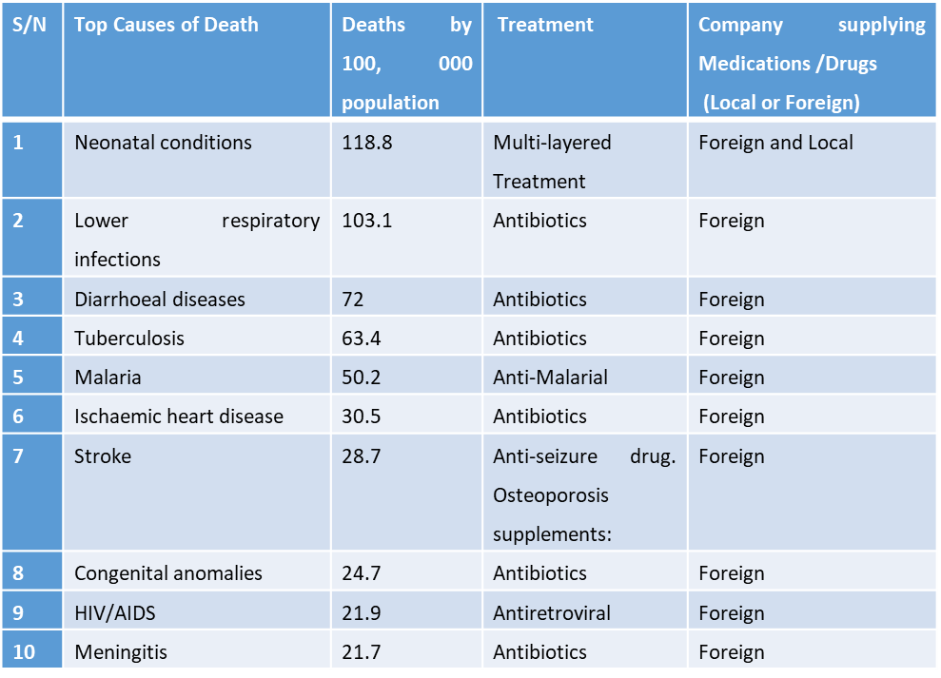
Figure 2: Top Causes of Deaths, Treatments and Companies producing Medications /Drugs
Source: Compiled by the authors from WHO (nd) Nigeria. https://data.who.int/countries/566.
Thirdly, policy inconsistencies and contradictions have undermined the effectiveness of government interventions. While the federal government has implemented price controls on food and private sector services, it has not reduced fees for its own services, particularly in healthcare. For instance, the government recently increased fees charged by the National Health Insurance Scheme (NHIS), now renamed NHIA. This policy reversal and contradiction have further undermined the credibility of government responses. As one policy commentator noted, “The high cost of drugs will persist, as local production is on the brink of collapse due to inconsistencies in government policies” (Ogundipe, 2024). The taxes imposed on the importation of certain drugs and reagents for local production have forced companies to raise drug prices. Stakeholders have argued that the government should provide more tax holidays and remove high tariffs introduced in recent years, as these costs are ultimately passed on to consumers and patients.
Fourthly, the poor business environment poses significant challenges for pharmaceutical companies and healthcare providers. Issues such as unreliable power supply, inadequate use of technology, inefficient and bureaucratic supply chains, and a complicated regulatory landscape create substantial obstacles. Additionally, problems like double taxation and insecurity, including kidnapping, further exacerbate these challenges. These adverse conditions have a ripple effect on the effectiveness of government responses and the overall functioning of the healthcare sector.The President of the Pharmaceutical Society of Nigeria (PCN), Prof Cyril Usifoh, emphasised the necessity of consistent electricity, stable foreign exchange rates, and sound fiscal policies to tackle the situation. Osifoh went further to state that:
We have a quarterly meeting with the Coordinating Minister of Health and the industries have put forward some of the things that are needed. They must create an enabling environment. If electricity is about 70 per cent okay, and the forex is stable, industrialists can plan. It becomes difficult to plan if the forex keeps changing every time (Adejoro, 2024b)
Fifthly, there have been issues of poor or weak regulatory control of the health sector in the country for a long time. This is partly as a result of incompetent regulators or overseers, politicisation of the agencies and insufficient funding of appropriate regulatory agencies. These regulatory agencies have now turned to business ventures to generate monies for the government. By this, National Agency for Food and Drug Administration and Control, now charge high cost of registering drug products and inspection fees. As a PCN official noted
The industry is having issues with payment as the NAFDAC Automated Product Administration and Monitoring System generated tariff is more than the Central Bank of Nigeria’s rate when calculated with the dollar fees on NAFDAC tariff. For example, the Tricyclic antidepressants fee for NAFDAC is $672.95 and conversion to naira using the current CBN rate of N 1, 593.91 to dollar brings the total payment to NAFDAC to N1,072,621.73. The online NAFDAC portal is N 1, 101, 061.25. However, on bank portals, the exchange rate ranges from N 1, 520 to N 1, 530 to a dollar; therefore, the NAFDAC fee to industry is actually $724.38 instead of the gazetted fee of $672.95. Who pays the difference? The Nigerian patients (Iremeka, 2024)

Sixthly, the brain drain and emigration of healthcare and medical practitioners have significantly impacted Nigeria. Many professionals, including doctors, pharmacists, radiologists, nurses, and midwives, have left the country to practice abroad. This migration is driven by factors such as inadequate working tools and equipment, poor welfare conditions, and insufficient investment in the healthcare sector. Since the announcement of subsidy removal in May 2023, approximately 1,197 Nigerian-trained doctors moved to the United Kingdom by January 2024, and the number may have increased by July 2024 (Sani, 2024). Additionally, Faruk Abubakar, Registrar of the Nursing and Midwifery Council of Nigeria, reported that over 15,000 nurses and midwives left the country in 2023 (Adejoro, 2024c).
Seventh, inadequate healthcare financing and corruption continue to plague Nigeria’s healthcare system. Despite various attempts to improve the sector, funding remains insufficient and poorly managed. Allocations to healthcare are often minimal and misused, with reports of corruption further undermining the effectiveness of available resources. Although national leaders have expressed commitment to prioritizing health, as evidenced by declarations such as the Abuja Declaration of 2001, the Addis-Ababa Declaration of 2006, and the Ouagadougou Declaration of 2008 (WHO, 2013), Nigeria has struggled to meet these goals. For example, a WHO (2013) study revealed that out-of-pocket expenditure still accounts for over 40% of total health expenditure in 20 out of 45 countries. Since President Bola Tinubu’s inauguration in May 2023, only 5.15% (1.48 trillion Naira) of the 28.7 trillion Naira 2024 budget has been allocated to the health sector (Budgit, 2024).
There has also been cases of corruption ravaging the sector just like the country as a whole. Pate said,
So when we look at the issue of corruption in Nigeria, which is very long-standing, it’s ubiquitous. I recently just dealt with another case where donated, ready-to-use therapeutic foods, were donated to feed acutely malnourished children, free of charge to where we have severe acute malnutrition. Somebody raised grants, raised resources, brought it to Abuja, deployed it to one of the state capitals, and they filtered away. So it (corruption) is a very deep issue. I have to write to the IG, and I would like to thank him also, specifically for deploying a very senior officer of the police force to be part of the task force. The challenge we face is a system and a paradigm that exists, that tolerates, encourages, demands, and accommodates corruption (Odeniyi, 2024).

Finally, the disconnection and fragmentation within Nigeria’s health system. The federal, state, and local levels operate independently rather than as an integrated national health system. This fragmentation is particularly concerning at the primary healthcare level, which is supposed to be the first point of contact for many Nigerians. Unfortunately, many primary healthcare centers and hospitals are underfunded and lack essential resources and trained personnel. As a result, a large portion of the population is forced to rely on secondary or tertiary healthcare centers or private facilities for their medical needs.
Discussion of Findings and Implications
The study's findings highlight several important themes. Firstly, the rising cost of drugs has had a significant impact on both healthcare and productivity. This increase in drug prices has negatively affected the quality of healthcare, consistent with global findings that high prescription drug costs lead to fewer patients receiving necessary medication. The high cost of healthcare services often results in untreated diseases, which can contribute to the spread of pandemics and epidemics. This aligns with O'Donnell's (2024) study, which links poor health to poverty by disrupting access to and retention of human capital and forcing people to sacrifice basic necessities for healthcare. Additionally, the study reveals that the high cost of transportation and services has deterred many individuals from seeking medical care, which is consistent with Jimenez's (2021) findings in the United States about how prescription drug costs impact healthcare quality. The study also notes that patients and individuals are increasingly relying on unqualified practitioners or folk medicine due to a lack of testing and diagnosis. Moreover, fluctuations in subsidies and foreign exchange rates have affected the cost of medical equipment, tools, and consumables. This has led to the use of non-standardized or improvised medical supplies, such as low-quality nose covers. Other public healthcare areas, including neurological, maternal, and sexual and reproductive health services, have also been impacted. These issues have implications for both individual health outcomes and population growth. Any wonder Ezem (2023) noted that
These products are pivotal in family planning, maternal health, and reproductive rights. The rise in prices poses a barrier to accessing contraceptives, particularly for low-income vulnerable individuals. This price hike creates a detrimental ripple effect on reproductive health, leading to reduced contraceptive access and usage higher maternal mortality rates and unintended pregnancies
Nigeria is already grappling with a high population growth, and scholars have debated whether this rapid expansion will hinder or promote the nation's development (Takambou, 2023). Challenges in the reproductive health sector could exacerbate this population explosion. The study also highlights the impact of brain drain and the mass exit of pharmaceutical companies. The loss of health professionals, along with those who would mentor future professionals, further weakens the sector. Additionally, more health professionals are planning to leave, compounding the problem. Another significant finding is the increased reliance on spiritual interventions, self-help measures, and unskilled healthcare providers. Research by Thompson, Kanumuangi, Aduradola, and Raheem (2023) shows how public policy can drive patients towards unqualified practitioners and spiritual remedies, negatively affecting the overall health of women and babies. Recently, former presidential aspirant Peter Obi noted that many Nigerian households now turn to prayers rather than seeking medical treatment (Chukindi, 2024). The dual policies of the government have also led to increased drug abuse and the proliferation of fake or adulterated drugs. Job losses in the sector are another consequence, with workers being retrenched or downsized. NAFDAC has raised concerns about the rise in fake importation documents and illegal marketing of counterfeit medicines (John, 2024). These findings align with Dawkins et al. (2023), reflecting the broader impact of these challenges on Nigeria’s healthcare system.
Secondly, the study findings indicate that the government has taken various actions to address healthcare challenges, including providing palliatives to workers and increasing the minimum wage. Additionally, the government has introduced policies aimed at developing and improving the healthcare sector. However, these interventions are not sufficient on their own and require strong political will and other supportive drivers. Spears (2017) similarly argues that effective health interventions depend on factors such as health behavior, social and economic environments, clinical care, and the physical environment. Omoleke and Taleat (2017) also suggest that the failure of healthcare interventions in Nigeria can be attributed to a lack of political will.
The findings of the study further show that these interventions have failed or partly succeeded as a result of its weaknesses and that these weaknesses emanates from failure of the government to carry the stakeholders along in its decisions and polices, the exodus of some big and foreign pharmaceutical companies, inconsistency and contradictions of policies, poor enabling or business environment, poor or weak regulatory control of the health sector in the country for a long time, brain drain and emigration of healthcare and medical practitioners, inadequate healthcare financing or funding and corruption, and disconnection or fragmentation between the systems of Healthcare. Studies have shown that these factors have enormous impact on any nation’s healthcare. Omoleke and Taleat (2017) describes Nigeria’s health polices as badly formulated, lack proper coordination neither are they related to any economic target. They then concluded that:
The Nigeria Health Sector is replete with inadequacies and shortcomings and weaknesses in the areas of capital, material and human resources which hinder effective health care delivery services. The Nigeria Health Sector can only be improved if Nigeria statesmen are less self centred but much more committed to health policy formulation, implementation, monitoring and evaluation (2017: 216).
These findings are consistent with previous and recent studies which have all established that these factors including public polices impact health to a large extent (Heller and Hsiao, 2007; Spears, 2017; Basha, 2023).

Conclusion
The paper has shown how public polices especially monetary policies can impact a nation and its critical sector such as healthcare. After President Bola Ahmed Tinubu announced the cancelation of the petrol subsidy, the repercussion was felt in almost every sector. One area that was also affected was the health sector. The study finds that these policies have raised the costs of essential drugs and healthcare services. While they have broadened access to health, they have also led to the exit of major pharmaceutical companies that Nigeria has relied on for years. Government initiatives, including palliatives and support for local production, have had limited success due to problems like corruption, inconsistent policies, lack of political will, and insufficient healthcare funding. The paper recommends the need for caution in implementing neo-liberal policies especially in a country like Nigeria where oil or petrol drive the economy, emphasizes the need for enhanced healthcare funding, greater support for domestic drug production, and stronger political commitment.

References
Abah, V. O. (2022). Poor health care access in Nigeria: A function of fundamental misconceptions and misconstruction of the health system. In Healthcare Access-New Threats, New Approaches. IntechOpen.
Adejoro L (2024a, July 19). Many Nigerians don’t seek medical care due to cost – Minister. Punch. https://punchng.com/many-nigerians-dont-seek-medical-care-due-to-cost-minister/
Adejoro, L (2024b, May 12) Rise in cost of drugs worsens access to healthcare delivery. Punch. https://punchng.com/rise-in-cost-of-drugs-worsens-access-to-healthcare-delivery/
Adejoro, L (2024c, February 13) 15,000 nurses left Nigeria in 2023 — Registrar, Nursing council. Punch. punchng.com/15000-nurses-left-nigeria-in-2023-registrar-nursing-council/
Agba, A., Ushie, E. M., & Osuchukwu, N. C. (2010). National Health Insurance Scheme (NHIS) and employees’ access to healthcare services in cross river state, Nigeria. Glob J Hum Soc Sci, 10, 9-16.
Anichukwueze D. (April 28, 2024). “Fuel Subsidy Removal Necessary For Nigeria Not To Go Bankrupt – Tinubu”. Available at: https://www.channelstv.com/2024/04/28/fuel-subsidy-removal-necessary-for-nigeria-not-to-go-bankrupt-tinubu/.
Balogun J. A (2021) The Nigerian Healthcare System: Pathway to Universal and High-Quality
Balogun, J. A. (2021). Nigerian Healthcare System, Pathway to Universal and High-Quality Health Care. Springer International Publishing. Available at: https://doi.org/10.1007/978-3-030-88863-3.
Basha, S (2023) Healthcare and Political Obstacles in the Way of Quality Healthcare. Health Politics and Polices, 1, 1: 14-22.
Budgit (2024) Nigeria’s 2024 Federal Government Budget: Federal Ministry of Health. https://budgit.org/post_infographics/2024-ministry-of-health-allocation/
Chang, H J (2007) Bad Samaritans: The Myth of Free Trade and the Secret History of Capitalism. London: Bloomsbury.
Chukindi, J (2024, June 26) Hardship: Prayers have replaced medicine in most homes in Nigeria – Peter Obi. Daily Post. https://dailypost.ng/2024/06/26/hardship-prayers-have-replaced-medicine-in-most-homes-in-nigeria-peter-obi/
Dawkins, B., Renwick, C., Ensor, T., Shinkins, B., Jayne, D., and Meads, D (2021) What factors affect patients’ ability to access healthcare? An overview of systematic reviews. 26, 10: 1177-1188
Doyle, B (2022, May 3) Health in African History. The History of African Development. 1- 20. https://www.aehnetwork.org/wp-content/uploads/2022/04/Health-in-Africa-for-AEHN-Handbook-FINAL-3-May-2022.pdf
Ezem (2023) The Unintended Consequences: Fuel Subsidy Removal and its Impact on Reproductive Health in Nigeria. LinkedIn. https://www.linkedin.com/pulse/unintended-consequences-fuel-subsidy-removal-its-md-mph-mba/
Garba, A. A. (2023). History of fuel subsidy removal in Nigeria. Available at: https://blueprint.ng/history-of-fuel-subsidy-removal-in-nigeria/.
Health Care. Switzerland: Springer.
Heller, P. S and Hsiao, W. C. (2007), What Macroeconomists Should Know about Health Care Policy. Washington: IMF

Idris, R. T. & Olawale Y. I. (2022). Reflection of Traditional Health Care Services: The example of Ilorin Emirate, Nigeria. In L. Odeh, P. Akanmiduu, and A. Danladi History, Indigenous Science and Technology and Economic Transformation in Africa. A Festschrift in Honour of Professor Raimi A. Olaoye, Excellent Press Services Limited, 2022, Chapter 22.
Ikpoto, E (2023, December 7). Five multinationals dump Nigeria in 10 months. Punch. https://punchng.com/five-multinationals-dump-nigeria-in-10-months/
Iremeka, C. (2024, March 19) ‘Weak regulatory control fuelling high drug cost’ Punch. https://punchng.com/weak-regulatory-control-fuelling-high-drug-cost/
Jimenez, D (2021_June 22) Studies reveal new evidence of impact of US drug price hikes on patients. Pharmaceutical Technology. https://www.pharmaceutical-technology.com/features/studies-us-drug-prices-patients/?cf-view
John, B (2024, April 11) NAFDAC raises alarm over fake anti-bacteria injection, deadly cough syrup. Premium Times. https://www.premiumtimesng.com/health/685271-nafdac-raises-alarm-over-fake-anti-bacteria-injection-deadly-cough-syrup.html
NAFDAC (2024, May 6). High Cost Of Medicines: Federal Government Assures Nigerians Of Determination To Make Drugs Affordable. Press Release. https://nafdac.gov.ng/high-cost-of-medicines-federal-government-assures-nigerians-of-determination-to-make-drugs-affordable/
Nkwam, F. E. (1988). British medical and health policies in West Africa c1920-1960. University of London, School of Oriental and African Studies (United Kingdom).
Nseyen, N (2024, July 15) Forex scarcity made pharmaceutical multinationals exit Nigeria – PMG-MAN. Daily Post. https://dailypost.ng/2024/07/15/forex-scarcity-made-pharmaceutical-multinationals-exit-nigeria-pmg-man/
Odeniyi (2024, July 18) Corruption in Nigeria’s health sector very deep — Minister. Punch. https://punchng.com/corruption-in-nigerias-health-sector-very-deep-minister/
Ogundipe, S (2024, July 4) High cost of drugs to persist as local production flops. Vanguard. https://www.vanguardngr.com/2024/07/high-cost-of-drugs-to-persist-as-local-production-flops/
Oluwabamide, A. J. (2013). Traditional medicine in Nigeria: The appraisal of an African cultural heritage. Abibisem: Journal of African Culture and Civilization, 6, 251-267.
Omoleke I. I and Taleat, B, A (2017) Contemporary issues and challenges of health sector in Nigeria. Res. J. of Health Sci. Vol 5(4): 210- 216
Onwuzoo, A (2024, February 4) Tinubu orders immediate action to curb rising drug prices. Punchhttps://punchng.com/tinubu-orders-immediate-action-to-curb-rising-drug-prices/
Owen O'Donnell, O (2024) Health and health system effects on poverty: A narrative review of global evidence, Health Policy, Vol. 142. https://doi.org/10.1016/j.healthpol.2024.105018.
Paul, I. A. (2020). A Historical Evaluation of the Prospects and Challenges of Nigeria’s Health Sector, 1960–2016. West Bohemian Historical Review, Vol. X, Issue 2, 201-224. https://dspace5.zcu.cz/bitstream/11025/42366/1/Paul.pdf.
Premium Times (2024, January 29) EDITORIAL: High costs of drugs: Declaring a state of emergency before many die. https://www.premiumtimesng.com/opinion/editorial/663146-editorial-high-costs-of-drugs-declaring-a-state-of-emergency-before-many-die.html?tztc=1
Sani N (2024, January 9) It’s One Doctor to 6,400 Patients in a Nigerian State. News Central Africa. https://newscentral.africa/its-one-doctor-to-6400-patients-in-a-nigerian-state
Spears, M (2017, May 4) 5 Ways Public Policy Impacts Health. The Sycamore Institute. https://sycamoretn.org/5-ways-public-policy-impacts-health/
Takambou, M M (2023, July 14). Nigeria's population boom: Path to poverty or prosperity? Deutsche Welle https://www.dw.com/en/nigerias-population-boom-path-to-poverty-or-prosperity/a-66186900
Thompson, O. (2024). ‘Beyond our pregnancies and bodies’: benefits and barriers to antenatal care clinic utilisation among pregnant women in Abeokuta, southwest Nigeria. African Identities, 1–18. https://doi.org/10.1080/14725843.2024.2388180
UNDP (2024, March) Breaking the gridlock: Reimagining cooperation in a polarized world. New York: UNDP.
WHO (2013, January) State Of Health Financing In the African Region. WHO: Brazzaville, Republic of Congo. https://www.afro.who.int/sites/default/files/2017-06/state-of-health-financing-afro.pdf
Yunusa, E., Yakubu, Y., Emeje, Y. A., Ibrahim, Y. B., Stephen, E., & Egbunu, D. A. (2023). Fuel subsidy removal and poverty in Nigeria: a literature review. GPH-International Journal of Applied Management Science, 4(09), 14-27.

